What is Components in angular???

=========================================

Angular working is completely based upon creating components. Components are created so that we can make

our complex application parts usable.

How to create components???

==========================================

We can create components at folder level, by right clicking and creating a file with the extension .ts.

This will be our new component , however we need to register the component in the module file as well.Also

we will need to create the html files as well as style files for the component. Instead of doing this we can

do it using the command cli which will generate all the files needed for us.

We can supply the command "ng g c component_name" to create the component.

Once we create the component we will get the same list of file which are present in the app folder referred

to as the root folder.

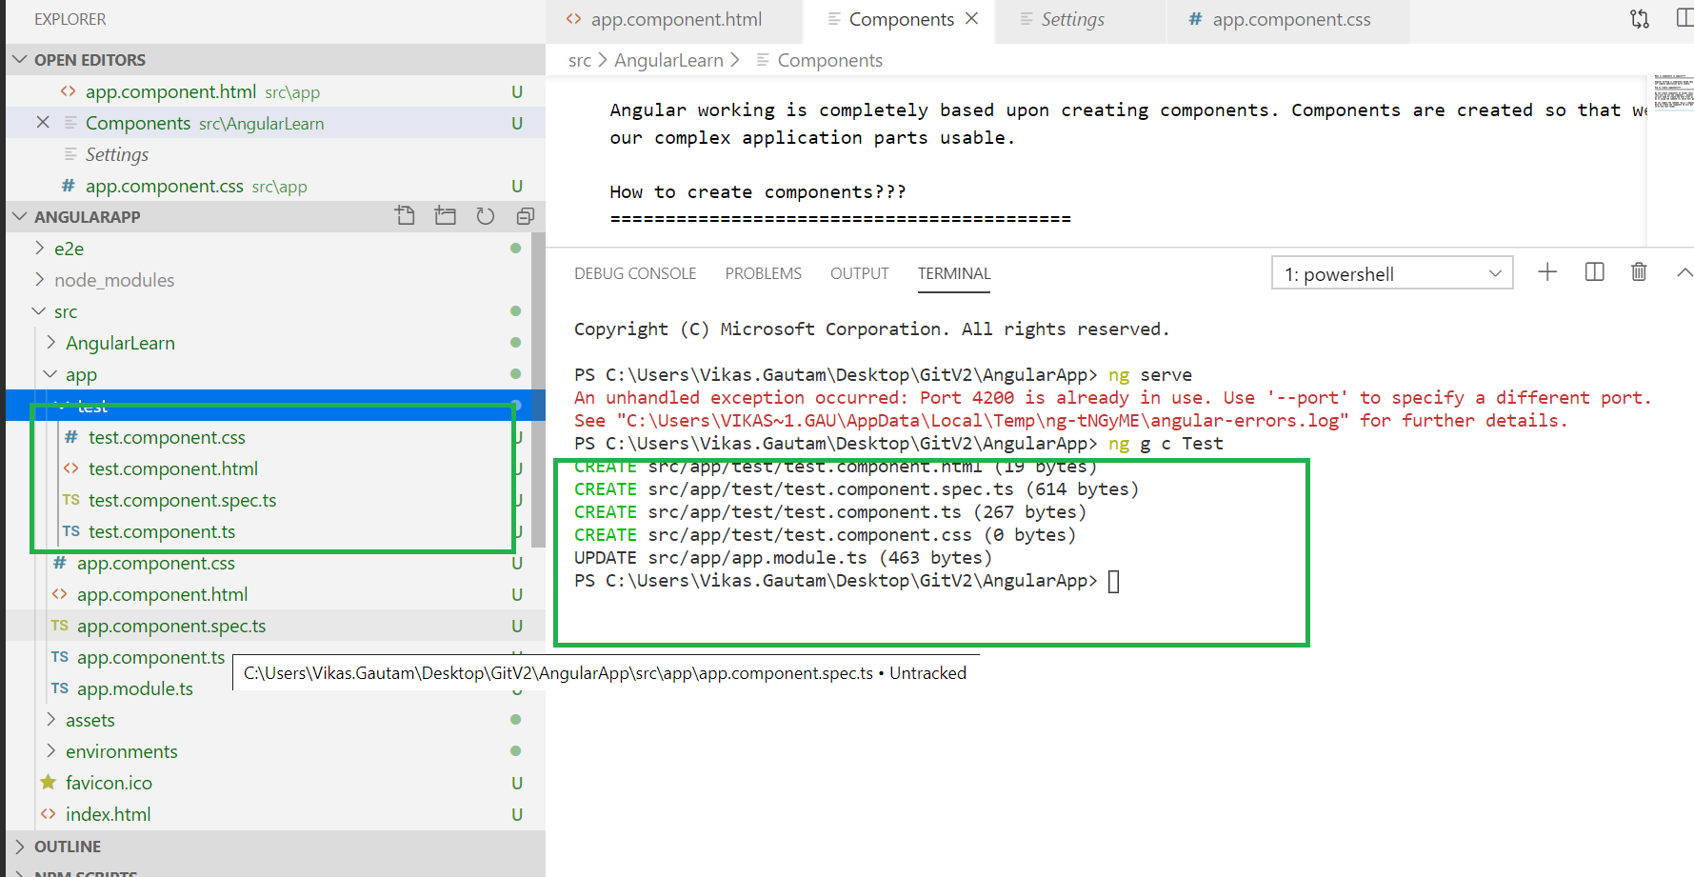

In the above image, you can see that a new component named "server2" is created. It contains the same other components which you have seen when we create a first app..

1. server2.component.css
2. server2.component.html
3. server2.component.spec.ts
4. server2.component.ts

Here, **server2.component.spec.ts** component is used for testing purpose. You can delete it by right click on that.